V.L Memorial Public School
475 Vijay Nagar
Chapter - 13 - Questions - Class7th - Maths
CLASS 07 - MATHS (GANITA PRAKASH)

 | Section A
1 | Heights of students are recorded in centimetres.  Which number below cannot be a possible observation?  a) 120  b) 160  c) - 150  d) 145 | [1]
2 | A dataset has values 10, 12, 14, 16, 100.  Which value affects the mean the most?  a) 16  b) 10  c) 12  d) 100 | [1]
3 | In a bar graph, the bars are drawn  a) in circular form  b) vertically only  c) horizontally only  d) vertically or horizontally | [1]
4 | If the minimum value of a dataset is 8 and the maximum is 42, the range is  a) 40  b) 26  c) 50  d) 34 | [1]
5 | In a bar graph, if 1 unit on the y - axis represents 5 students, a bar of height 6 units shows  a) 60 students  b) 30 students  c) 11 students  d) 35 students | [1]
6 | The double bar graph shows rainfall (in mm) for two cities over 6 months. If City A always has taller bars than City B, what does it indicate?  a) City A is smaller than City B  b) City A receives more rainfall than City B  c) City B is colder  d) Both cities receive equal rainfall | [1]
7 | The median of 2, 5, 7, 9 is  a) 7  b) 8  c) 6  d) 5 | [1]
8 | If the scale of a graph is 1 cm = 10 units, a bar of height 4 cm represents  a) 10 units  b) 30 units  c) 40 units  d) 20 units | [1]
9 | A school recorded the number of boys and girls participating in sports across different classes. To compare their participation easily, the best graphical representation would be  a) Histogram  b) Pie chart  c) Double bar graph  d) Line graph | [1]
10 | The daily temperatures (in °C) recorded for 5 days are 30, 32, 31, 33, 30.  How many observations are there in the dataset?  a) 4  b) 30  c) 156  d) 5 | [1]
11 | Identify the outlier in the data: 4, 5, 6, 7, 25.  a) 7  b) 5  c) 4  d) 25 | [1]
12 | Find the mean of: 10, 15, 20, 25.  a) 17.5  b) 18  c) 20  d) 15 | [1]
13 | In a hospital, a nurse noted the body temperatures of patients on a chart. Which type of graph is best suited to represent this data visually?  a) Dot plot  b) Double bar graph  c) Pictograph  d) Bar graph | [1]
14 | Which data set has a median equal to 6?  a) 4, 5, 8, 9  b) 2, 4, 5, 8, 10  c) 1, 3, 5, 7  d) 6, 6, 6, 6 | [1]
15 | A teacher prepared a bar graph showing the number of students choosing different fruits - apple, mango, banana, and orange. If two fruits have equal bar heights, what does it mean?  a) Both fruits are liked by equal number of students  b) The teacher made a mistake  c) Both fruits have equal weights  d) Both fruits are expensive | [1]
16 | The average of 4 numbers is 18.  What is the sum of the numbers?  a) 36  b) 90  c) 22  d) 72 | [1]
17 | The mean of 3, 5, 7, 50 is  a) 16.25  b) 12  c) 10  d) 65 | [1]
18 | A data set consists of marks of 40 students.  How many numerical values does the dataset contain?  a) 80  b) 20  c) 40  d) 39 | [1]
19 | If one very large value is added to a data set, which value will change the most?  a) Frequency  b) Smallest value  c) Mean  d) Median | [1]
20 | Find the median of: 8, 4, 6, 10, 12.  a) 8  b) 6  c) 10  d) 12 | [1]
21 | Assertion (A): The range of a data set gives information about the average of the data.  Reason (R): The range is the difference between the maximum and minimum values.  a) Both A and R are true and R is the correct explanation of A.  b) Both A and R are true but R is not the correct explanation of A.  c) A is true but R is false.  d) A is false but R is true. | [1]
22 | Assertion (A): The median of a data set remains the same even if an extremely large value is added.  Reason (R): Median depends only on the position of values, not on their magnitude.  a) Both A and R are true and R is the correct explanation of A.  b) Both A and R are true but R is not the correct explanation of A.  c) A is true but R is false.  d) A is false but R is true. | [1]
23 | Assertion (A): Mean is always the best representative value for a data set.  Reason (R): Mean is affected by extreme values in the data.  a) Both A and R are true and R is the correct explanation of A.  b) Both A and R are true but R is not the correct explanation of A.  c) A is true but R is false.  d) A is false but R is true. | [1]
24 | Assertion (A): The question “How many students are present today in the class?” is a statistical question.  Reason (R): Statistical questions usually involve variability in data.  a) Both A and R are true and R is the correct explanation of A.  b) Both A and R are true but R is not the correct explanation of A.  c) A is true but R is false.  d) A is false but R is true. | [1]
25 | Assertion (A): A bar graph can be used to compare different categories of data.  Reason (R): A bar graph shows data using pictures instead of bars.  a) Both A and R are true and R is the correct explanation of A.  b) Both A and R are true but R is not the correct explanation of A.  c) A is true but R is false.  d) A is false but R is true. | [1]
26 | If the scale of a bar graph is 1 cm = 5 students, what does a bar of height 7 cm represent? | [1]
27 | What is the purpose of using a bar graph? | [1]
28 | Identify the outlier in the data: 5, 7, 8, 9, 50. | [1]
29 | State whether the following is a statistical question. Give reason.  “How many hours do students of Class 7 spend watching TV daily?” | [1]
30 | The marks of 6 students in Mathematics are: 42,38,50, 40,60,45. Find the mean marks. | [1]
31 | Find the range of the data: 12, 18, 25, 30, 15. | [1]
32 | Find the median of: 4, 6, 8, 10. | [1]
33 | The mean of 8 observations is 12. Find their total. | [1]
34 | Find the mean of the first five even natural numbers. | [1]
35 | The data set is: 4, 6, 7, 8, 30.  - Identify the outlier.  - State which is a better representative value for this data - mean or median. | [1]
36 | - Write one statistical question related to marks.  - Write one non - statistical question related to marks. | [1]
37 | The data is: 5, 9, 3, 7, 11.  - Arrange the data in ascending order.  - Find the median. | [1]
38 | A bar graph shows the number of books sold in five days.  - Which feature of the graph tells how the numbers are represented on the axis?  - Name one type of graph suitable to compare data of two shops. | [1]
39 | The heights (in cm ) of 7 students are: 120,125,118,130,122,126,124. Find the mean and median height.  Represent the data and mean and median using dot plotting. | [1]
40 | The mean of 5 observations is 14.  - Find the total of the observations.  - If four observations are 10, 12, 15 and 13, find the fifth observation. | [1]
41 | In a bar graph, the scale is 1 cm = 10 students.  - What number of students is represented by a bar of height 4 cm?  - Name the type of graph used to compare the number of boys and girls in a class. | [1]
42 | State whether the question “How many hours do students of Class 7 study daily?” is statistical or not. Give one reason. | [1]
43 | The marks obtained by a student in 4 tests are 12, 15, 18 and 15.  - Find the mean marks.  - State whether the mean is a whole number or not. | [1]
 | Section B
44 | Match the following: 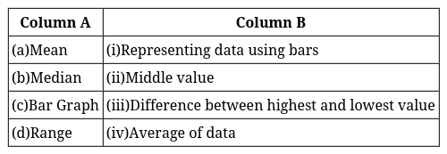 | [2]
 | Section C
45 | The marks (out of 100) obtained by a group of students in a class test are 45, 96, 80, 76, 40, 90, 55. Another section scores are 68, 76, 92, 48, 59, 86, 96. Compare and describe both the groups performance using mean and median. | [3]
46 | The following data shows number of mangoes on a tree for 8 weeks:  4, 5, 4, 6, 150, 3, 5, 4  The value 150 is suspected to be an outlier.  - Compute the mean and median with the outlier.  - Compute the mean and median without the outlier.  - Explain which measure (mean or median) better represents the data. | [3]
47 | A cricket team played 5 matches and scored:  84, 13, 0, 57, 51  - Calculate the mean runs per match.  - Find the median.  - Explain how the “0” run affects the mean but not the median. | [3]
48 | Given two datasets:  Dataset A: 10, 20, 30, 40, 50  Dataset B: 5, 15, 25, 35, 50  Calculate the mean for both datasets and compare the results. | [3]
49 | The heights (in cm) of 9 girls in a class are:  139, 142, 145, 150, 152, 138, 147, 140, 190  - Find the mean and median.  - Identify the outlier and recalculate mean without it.  - Explain whether mean or median represents the group better. | [3]
50 | Two cities recorded the monthly rainfall (in mm) for 6 months:  City A: 120, 118, 125, 119, 600, 123  City B: 140, 142, 138, 141, 139, 143  - Compare the variation in the two cities.  - Which city’s average rainfall is more meaningful? Explain. | [3]
51 | Explain the impact of extreme values (outliers) on the mean and median with an example. | [3]
52 | What does the "mean" represent in a dataset? Explain with an example. | [3]
53 | In a dataset, the values are: 10, 20, 30, 40, 50, 60. If we add 100 to each value, what will be the new mean? | [3]
54 | Below are monthly sunshine hours (average per day): 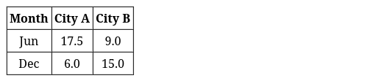  Using this information alone, answer:  - Which city is in the Northern Hemisphere? Explain.  - Which city has greater seasonal variation?  - Which measure (mean or median) is more meaningful for analyzing yearly daylight trends? | [3]
 | Section D
55 | Read the following text carefully and answer the questions that follow:  A fitness app records the number of steps walked by Riya over 7 days:  5200, 5500, 6000, 6200, 8000, 12000, 14000 Questions:  - Calculate the average number of steps walked per day. (1)  - Find the central value of the data. (1)  - Compare the values obtained in (a) and (b). What does this tell you about Riya’s walking pattern? (2)  - OR  - Which value better describes Riya’s regular activity level? Give a reason. (2) | [4]
56 | Read the following text carefully and answer the questions that follow:  The time (in minutes) taken by students to complete homework is:  20, 22, 25, 25, 25, 27, 30 Questions:  - Calculate the average time taken. (1)  - Identify the value that appears most frequently. (1)  - What does this frequent value indicate about students’ study habits? (2)  - OR  - If a new student usually finishes homework in about the same time as others, what time should they expect? Explain. (2) | [4]
57 | Read the following text carefully and answer the questions that follow:  The marks obtained by 10 students in a surprise test are:  12, 14, 15, 15, 16, 17, 18, 19, 20, 45 Questions:  - Find the average marks scored. (1)  - Find the central value of the data. (1)  - Identify one value that makes the data uneven. Explain its effect. (2)  - OR  - Which value should be used to judge the class performance fairly? Give a reason. (2) | [4]
 | Section E
58 | Here is a dot plot of the number of goals scored in each of Bob’s soccer games.  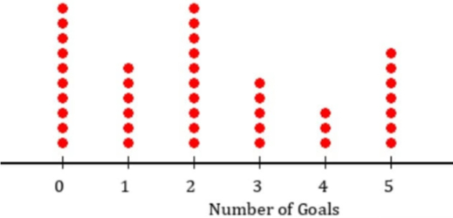  - How many times were five goals scored?  - Which number of goals were scored equally and most often?  - How many games were played in total? | [5]
59 | Observe the following data: 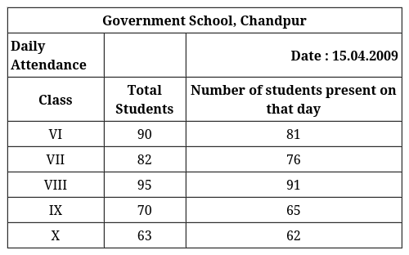  - Draw a double bar graph choosing an appropriate scale. What do you infer from the bar graph?  - Which class has the maximum number of students?  - In which class, the difference of total students and number of students present is minimum?  - Find the ratio of number of students present to the total number of students of Class IX.  - What percent of Class VI students were absent? | [5]
60 | How does a clustered bar graph help compare two sets of data? Give an examples. | [5]
61 | The table below shows daily temperatures for a city recorded for 5 days in degrees Fahrenheit. 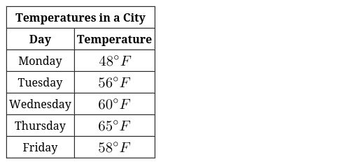  - What is the temperature recorded on Wednesday?  - On which day was the highest temperature recorded?  - Which day showed a decrease in temperature compared to the previous day?  - What is the difference in temperature between Monday and Tuesday?  - Describe the trend in temperatures over the 5 days. | [5]
62 | The dot plots below show the distribution of the number of pockets on clothing for a group of boys and for a group of girls.  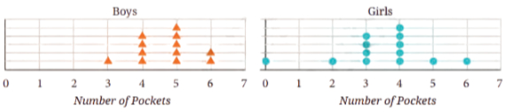  Based on the dot plots, which of the following statements are true?  - The data varies more for the boys than for the girls.  - The median number of pockets for the boys is more than that for the girls.  - The mean number of pockets for the girls is more than that for the boys.  - The maximum number of pockets for boys is greater than that for the girls. | [5]
63 | The mean of 6 numbers is 14.5. Five of the numbers are 12, 15, 9, 18, and 13. Find the missing number. Also check whether the new set’s median is the same as before when the missing number is included. | [5]
64 | Marks of 7 students (out of 100): 55, 60, 65, 72, 58, 75, 70.  - Find the mean and the median.  - If an 8th student scores 90, find the new mean and new median. | [5]
65 | Given two datasets of salaries for two companies: Dataset A: 25,000, 30,000, 35,000, 40,000, 45,000 and Dataset B: 25,000, 30,000, 35,000, 40,000, 200,000, calculate and compare their means and medians. Discuss the implications of the results for a decision - making scenario. | [5]
66 | The table below shows Ram’s weight in kilograms for 5 months. 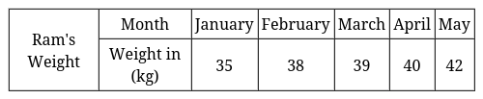  - What was Ram’s weight in January?  - In which month did Ram’s weight reach 40 kg?  - What is the difference in Ram’s weight between February and March?  - By how many kilograms did Ram’s weight increase from January to May?  - Describe the trend in Ram’s weight over the 5 months. | [5]
67 | The table shows the number of hours two students studied during a week: 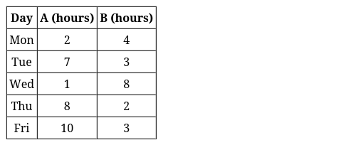  - Find the mean and median study hours for each student.  - Who has more consistent study pattern? Justify using variability. | [5]
 | Section F
68 | Fill in the blanks:  - A question that expects answers with variability is called a ________ question.  - Heights of students in a class form a ________ data set.  - The median of the data 3, 5, 7, 9, 11 is ________.  - A bar graph uses________bars to represent data.  - The difference between the maximum and minimum values of a data set is called the ________.  - Mean is calculated by dividing the ________ of observations by their number. | [6]

